University of Utah Department Chartfield Registration Example:

Josh is a U of Utah Neuroscience Grad student who will share a room with his lab mate Patrick, also a Neuroscience grad. Josh can use the **U Utah Neuroscience Program - Snowbird Registration via U of Utah Department Chartfields only** page to register since he has been approved to use his Pi’s chartfield to pay for fees.

Josh will register as a **U. Utah Neuroscience Program Grad Student** and fill out the information completely including their UNID and chartfield string.

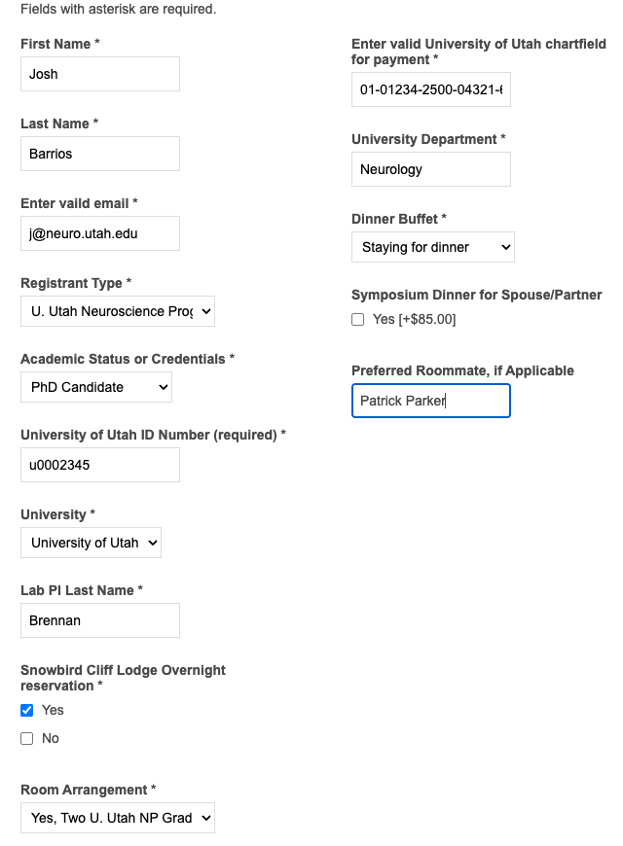

Before checking out, Josh will register Patrick by selecting REGISTER & ADD ATTENDEE. Note: Josh may opt to have Patrick register himself separately. In which case, Josh may just Register & Checkout.

Otherwise, Josh will fill in form with Patrick’s information and add his registration. (No need to select additional dinner). Josh will select the overnight stay with the room arrangement of “Yes, room booked and shared with Registrant listed below”, enter his name and UPDATE the cart.

Finally, Josh will review their order, click the box to “agree with the terms of service…” hit CHECKOUT. Jeff may choose to create an account or checkout as a Guest. Complete the billing information and submit the order.

If you have additional questions or need assistance, please reach out to the program manager, [nicole@neuro.utah.edu](mailto:nicole@neuro.utah.edu)

Sample Checkout:

SELECT **UPDATE** > enter credit card info and select check robot prompt and select **CONFIRM**. You will receive an email from Utah Health Store indicating your order is received but not confirmed. An additional email will arrive once your order is confirmed, or your order required more information.